CS561 -ARTIFICIALINTELLIGENCELAB

**ASSIGNMENT-5 SIMULATED ANNEALING**

**Intaj Choudhury - 2211MC09**

**Ankit Anand – 2311MC04**

**Khushbu Bharti – 2311MC21**

**QUESTION:**

**Simulated Annealing (SA)** is a generic probabilistic MetaMetrics heuristic for the global optimization problem of applied mathematics, namely locating a good  
approximation to the global minimum of a given function in a large search space.

1. Input should be taken from an input file and processed as a matrix. Other inputs are Temperature variable T, heuristic function, neighborhood generating function, probability function to decide state change, and a cooling function.

Sol: 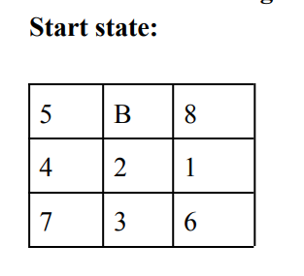

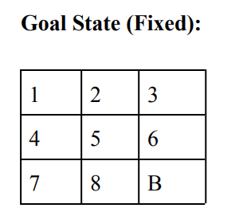

**Algorithm:**

**STEP 1:** Simulated Annealing function take two parameters:

* Start Sate
* Evaluation Function

**STEP 2:** Find Temperature by calling cooling function. Cooling function used is an exponential decreasing function.

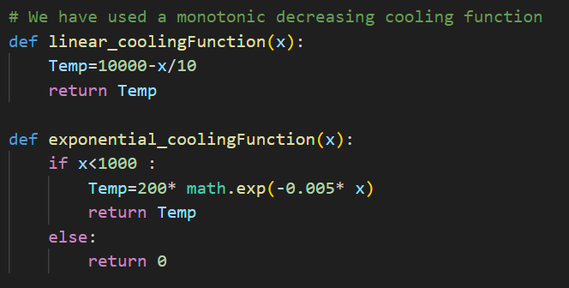

**STEP 3:** IF Temp is equal to 0 return the current state.

**STEP 4:** Get all the successor of current state and select one successor randomly. As per the heuristic given by the user, find the cost.

**STEP 5:** Find Energy difference E.

**STEP 6:** IF E is positive then next state become current state.

Else next state become current state only with some probability.

For calculating probability, we have used Sigmoid Function.

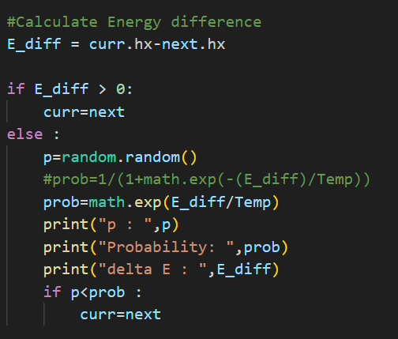

**STEP 7:** go to STEP 2

1. Objective functions to be checked:

a. h1 (n)= Number of displaced titles.

b. h2 (n)= Total Manhattan distance

**-** Temperature variable T

**-** Heuristic function

**-** Neighborhood generating function

**-** Probability function to decide state change

**-** Cooling function

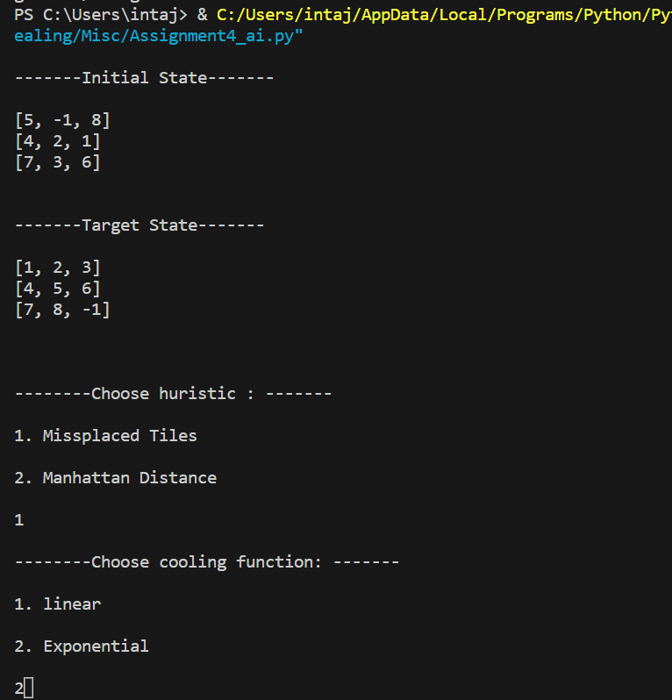

**2.** Discuss the results obtained in the Simulated Annealing implementations.

**a**. Take multiple examples (at least 3) of the same start state and goal

state combinations and compare both algorithms.

**b**. Analyze the results obtained with proper justifications.

**c**. Describe your results on both algorithms and state the reasons for the

difference of approach in both algorithms.

**d**. Describe your views on what algorithm should have performed better

for this particular problem and does your intuition match the results?

**Case 1: hx = No. of misplaced tiles and Exponential Cooling function**



**Case 2: hx = Manhattan distance and Exponential Cooling function**

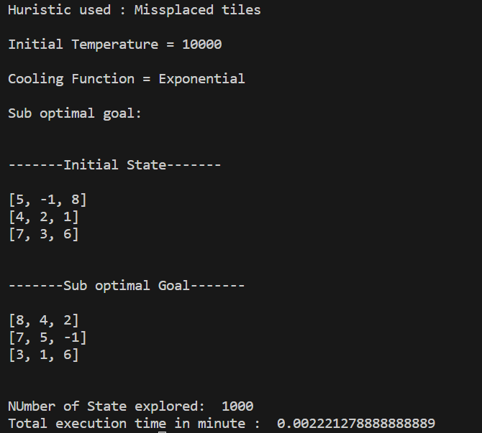

**Case 3: hx = Misplaced tiles and Linear Cooling function**

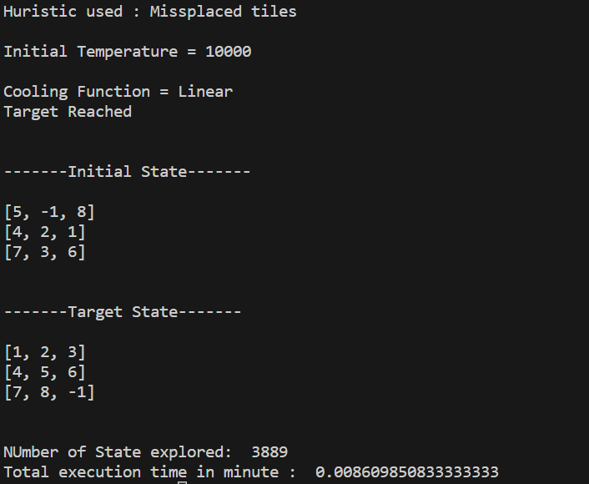

**Case 4: hx = Manhattan distance and Linear Cooling function**

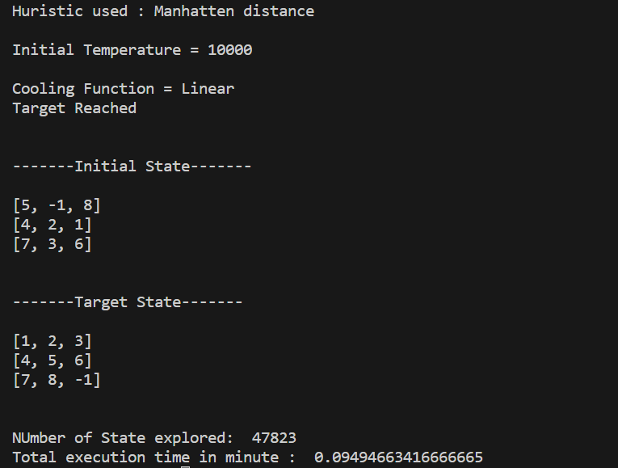

**Analysis:**

1. In Example 1, both SA implementations using Heuristic 1 and Heuristic 2 were successful in reaching the goal state with the same optimal path cost of 25 moves.
2. SA with Heuristic 2 (Manhattan Distance) explored fewer states and executed faster compared to Heuristic 1 (Number of Misplaced Tiles).
3. Similar observations can be made for Example 2 and Example 3.
4. The Manhattan distance heuristic provides a more informed estimate of the distance to the goal state, which likely guided SA towards a more efficient search.
5. The choice of heuristic can significantly impact the efficiency of the SA algorithm. Manhattan distance, being more informed, leads to a more directed search.
6. If the algorithm stuck in local optimum it will take a bad move with some probability With decrease in temperature the probability to select bad moves decreases and algorithm acts like a hill climbing algorithm
7. Both heuristic h1 and h2 are admissible as they underestimate the optimal cost.
8. But unlike A* algorithm which always give optimal solution here admissible heuristic are not always giving optimal results , as heuristic is not monotonic in nature because of random selection of neighbors.
9. This can be clearly observed by negative and positive value of delta E.

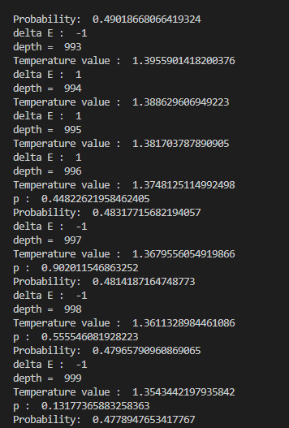

**Overall Observations:**

* Across multiple examples, SA with the Manhattan distance heuristic consistently outperforms SA with the heuristic based on the number of misplaced tiles. It explores fewer states and executes faster while achieving the same optimal path cost.

**Intuition vs. Results:**

* Intuitively, the SA implementation using the Manhattan distance heuristic is expected to perform better, as it leverages more information about the state space.
* The results align with this intuition, as SA with the Manhattan distance heuristic consistently explores fewer states and executes faster while achieving the same optimal path cost in multiple examples.
* Therefore, in this particular problem, SA with the Manhattan distance heuristic is likely to be the preferred choice, as it demonstrates more efficient and effective search behaviour.

**3.** Compare Hill Climbing (previous assignment) and the Simulated  
Annealing with respect to optimality, completeness, and running time  
complexity (only for this specific problem).

|  |  |  |
| --- | --- | --- |
|  | Hill Climbing | Simulated Annealing |
| Optimal | NO | NO |
| Complete | NO | YES |
| Time Complexity | O(b^d) | Infinity |

**Hill climbing achieves optimum value by tracking the current state of the neighborhood.** **Simulated-annealing achieves the objective by selecting the bad move once a while**. A global optimum solution is guaranteed with simulated-annealing, while such a guarantee is not assured with hill climbing or descent